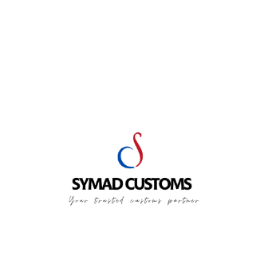

CLEARANCE GUARANTEE – SYMAD CUSTOMS

I, the undersigned ………………………………………………………………………….. hereby declare that with regard to the Transit customs declaration issued by the French entity Symad Customs, authorized under customs approval number 00006328, I undertake to arrange the transport of the goods directly to the customs office of destination in order to ensure clearance of the issued Transit document. Arrival must occur before the expiry of the validity period stated on the Transit.
I irrevocably and unconditionally agree to indemnify Symad Customs for any financial or legal consequences arising directly or indirectly from this operation, including but not limited to:
- All costs, duties, taxes, levies, interest and penalties of any kind, claimed by customs authorities or third parties, in connection with services performed at my request.

- Any liability or obligation falling on Symad Customs under legal or regulatory provisions, particularly if the competent authorities pursue Symad Customs for payment of taxes, penalties, duties or claims, including cases where guarantees or securities have been provided by or on behalf of Symad Customs.

- I undertake to pay all such amounts upon first request from Symad Customs, without delay or condition.

Name of Authorized Signatory – Date and Place | Signature and Company Stamp:

